Notes on template pattern

1. Template pattern is a kind of behavioral design pattern.
2. Think in term of “template”. Used in situation where overall flow(algorithm) is same but subclasses may add additional functionality.
3. <https://upload.wikimedia.org/wikipedia/commons/5/52/Template_Method_UML.svg>  
   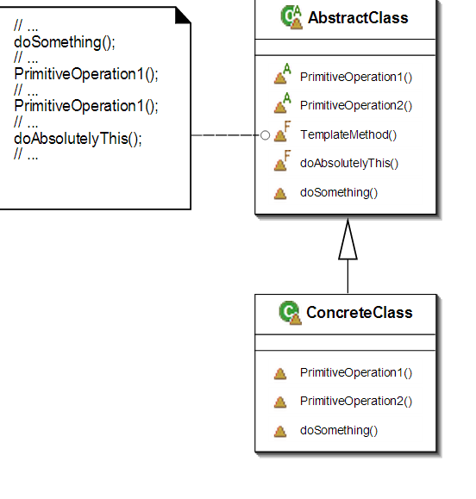
4. A
5. A